Membership Form

1. Your Details.
Membership is free. Please tell us as much or as little as you wish in order to register with us. Please complete the following to register with us. Remember to call us with any problems, concerns or issues you want to chat through with somebody.
1. Your name
Title: ______________ First Name: _______________________________________
Last Name: ____________________________________________________________

2. Your Contact Details
Organisation (if applicable):

Address:

Post Code:

Home phone:

Mobile phone: ________________________

Email address:

3. Please tick AT LEAST ONE of the following which applies to you

☐ I am personally affected by 22q deletion.

☐ I am personally affected by 22q duplication.

Other _________________________________

Gender: M / F Date of Birth:

☐ I am a relative or carer of a person/s with 22q

☐ I am an Education or Other Service Provider.* Please state:

☐ I am a Medical Professional.* Please state specialism:

☐ I am interested in Fundraising for Max Appeal.

4. Details of those/other people in your household affected by 22q deletion/duplication:
First Name | Last Name | Gender (m/f) | Deletion or Duplication | DOB (dd/mm/yy) | Relationship to you*
5. Other household members: (if over 18 – please ask their permission)
First Name | Last Name | Gender (m/f) | DOB (dd/mm/yy) | Relationship to you *

* Relationship to you: A=Partner B=Foster / Adoptive Parent C=Parent/Carer, D= Step-Parent, D=Grandparent, E= Sibling if other please write in the box.
6. How did you hear about Max Appeal: ____________________________________
7. Overview/Questions
What are your reasons for joining Max Appeal?

Keeping in touch.

How would you like to hear from us?

We would love to send you information on our services and information and you can help us through fundraising, events and volunteering opportunities

Please tick below to tell us how you want to hear from us

Please note that the details which you have provided on this form will be held on a secure computer and may also be held in a manual filing system. We will process your information to provide our support and services to you. We take your privacy seriously and will never sell or swap your details to third parties.

You can withdraw your consent to be contacted at any time by emailing info@maxappeal.org.uk
Information about how we protect and use your personal data is set out in our privacy policy:
https://www.maxappeal.org.uk/about/data_protection_and_privacy_statement

☐ Yes please I would like to receive communication by email
☐ Yes please I would like to receive communication by telephone
☐ Yes please I would like to receive communication by mobile (text message)
☐ Yes please I would like to receive communication by post

Signature: Date:

Post to: “Freepost Max Appeal” Phone: 0300 999 2211 email: info@maxappeal.org.uk
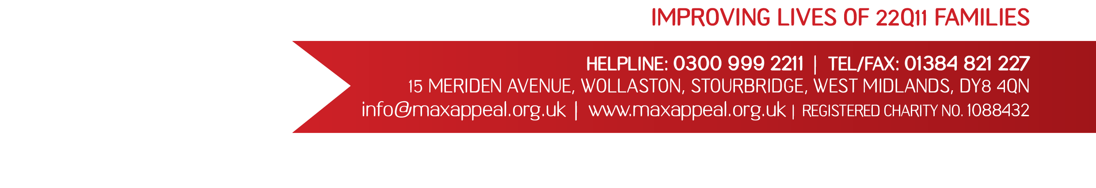
Registered office address:

