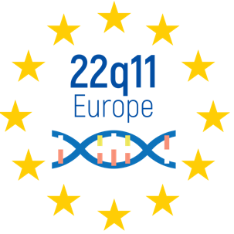

4th European Conference - Berlin

20 & 21 November 2021

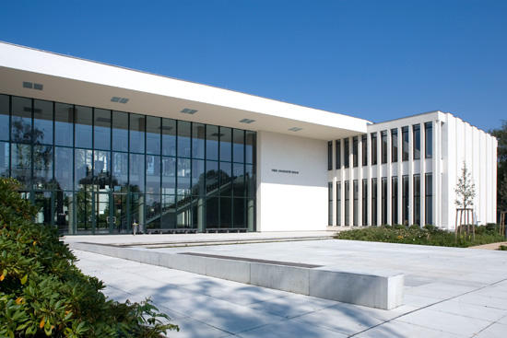

Location:

Registration:

More information: 22q11europe.org

Program

Saturday (November 20th)

08:30 – 09:15 Arrival and registration

09:15 – 09:25 Welcome Paul Havelange
Thomas Franken

09:25 – 09:40 General introduction and primer Prof. Maude Schneider
University of Geneva

09:40 – 10:20 Keynote 1: Medical, speech therapy Prof. Robert Sader
and audiological aspects of language University hospital Frankfurt
acquisition and speaking ability. Prof. Christiane Hey
Diagnostics and ways of treatment. University hospital Marburg

10:20 – 10:50 Workshop: interprofessional collaboration
(animated by Prof. Robert Sader and Dr. Ulrike Wohlleben)

10:50 – 11:20 COFFEE BREAK

11:20 – 12:30 Short presentations based on call for abstract
(15’ presentations made by young researchers
On various 22q11 related topics)

12:30 – 13:45 LUNCH BREAK WITH POSTER PRESENTATIONS

13:45 – 14:25 Keynote 2: what’s new in 22q11DS? Prof. Beata Nowakowska
University of Warsaw
Dr. Corrado Sandini
University of Geneva

14:25 – 14:45 Personal experience

14:45 – 15:15 Rehabilitation and therapy center: Stephan Schmid
a physical place of interdisciplinarity Honorary Chairman Wir sind 22q

15:15 – 15:45 COFFEE BREAK

15:45 – 16:25 Keynote 3: Aspects of school and learning Prof. Ann Swillen
KU Leuven
Dr. Edward Moss
CHOP Philadelphia

16:25 – 17:05 Workshop: Debate on school and learning issues
(animated by Prof. Ann Swillen and Dr. Edward Moss)

17:05 Adjourn

19:30 DINNER

Sunday (November 21st)

09:00 – 09:10 Arrival and welcome

09:10 – 09:40 Keynote 4: Orthopedic care in 22q11DS Prof. Ralf Stücker
Altona Children's Hospital Hamburg

09:40 – 10:10 Keynote 5: What do we know about Prof. Marcel Romanos
prevention of psychiatric disorders and University Hospital Würzburg
how does this apply to 22q11DS?

10:10 – 10:50 Workshop: stress and relaxation

10:50 – 11:20 COFFEE BREAK

11:20 – 12:00 Short presentations based on call for abstract

12:00 – 12:40 Keynote 6: Growing up with 22q11DS Prof. Therese van Amelsvoort
Maastricht University
Dr. Erik Boot
‘s Heeren Loo

12:40 – 13:20 Workshop: living as an adult (animated by Prof. Therese van Amelsvoort,
Dr. Erik Boot, and Daniella Krijger)

13:30 – 13:50 Personal experience

13:50 – 14:10 Goodbye and adjourn

Keynote speakers

Prof. Therese van Amelsvoort, Maastricht University
Department of Psychiatry and Psychology
Maastricht, the Netherlands
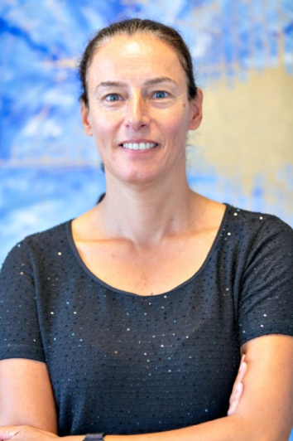
Therese van Amelsvoort is professor of Transitional Psychiatry and consultant Psychiatrist at Maastricht UMC. After finishing her medical studies in Rotterdam (1991), she worked as a medical and scientific advisor in Basel (Switzerland, 1991-1993) and as a resident in psychiatry in Luxemburg (1993-1994). Subsequently, she trained as an academic psychiatrist at The Maudsley Hospital / Institute of Psychiatry in London (UK, 1994-2001). She has had a longstanding interest in neurobiological mechanisms underlying psychosis and neurodevelopmental disorders, in particularly 22q11DS. She obtained her PhD on 22q11DS in 2004 at the University of Amsterdam. Since 2012 she is working at The Department of Psychiatry and Psychology at Maastricht University Medical Centre, running the Dutch adult 22q11DS clinic and with a special focus on the transition from adolescence to adulthood in both her clinical and academic work. She is co-founder of @ease, the Dutch variant of the successful Australian Headspace, an innovative youth mental health service.

Dr. Erik Boot
‘s Heeren Loo
Maastricht, the Netherlands

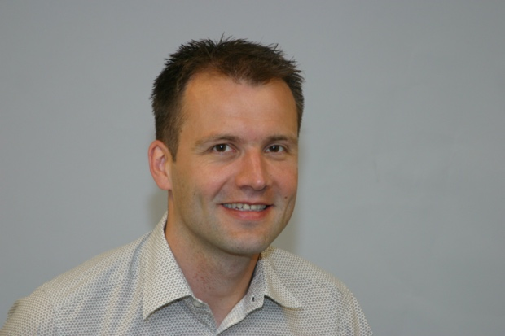
Erik Boot is a physician specialized in intellectual disability medicine and works at the multidisciplinary 22q11.2 clinics for adults at ‘s Heeren Loo and Maastricht, the Netherlands. He obtained his MD at the University of Amsterdam in 1999, completed his medical specialty training at the Erasmus University in Rotterdam in 2004, and completed his PhD thesis on adults with 22q11.2 deletion syndrome at the University of Amsterdam in 2010. From 2014 to 2016, Dr. Boot trained as a post-doctoral fellow in the Department of Psychiatry at the University of Toronto, Canada. This was a clinical and research fellowship program at The Dalglish Family 22q Clinic; an interdisciplinary clinic devoted to adults with 22q11.2 deletion syndrome and their families. He is a member of the scientific advisory committee of the national 22q11.2 family network (Stichting Steun 22Q11), and an advisor for the international 22q11.2 Society.

Dr. Edward Moss
Children Hospital of Philadelphia (CHOP)
Philadelphia, USA
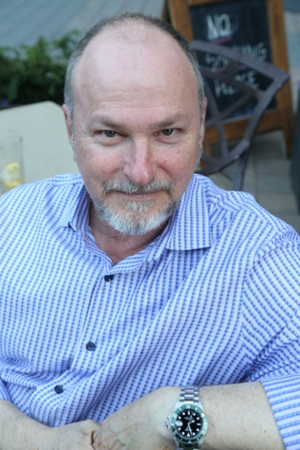
Dr. Edward Moss completed his doctoral training at the City University of New York. He is a developmental neuropsychologist, and former founder and Director of Developmental Neuropsychology at The Children’s Hospital of Philadelphia (CHOP). Over his career, Dr. Moss has received grants from several federal and private nonprofit foundations, to study normal brain development, the effects of poverty on brain development, and the relationship of 22q11.2 deletions on brain development and educational achievement. Dr. Moss specializes in assessing the effects of genetic disorders on cognitive and emotional development, and since 1994 has been working with children and families affected by 22q11.2 deletions and duplications. Now that many of the children he follows have become young adults, he has turned his attention to their interests in continued academic pursuits, career planning, mental health, and increasing independent living skills.

Beata Nowakowska

Marcel Romanos

Robert Sader

Dr. Corrado Sandini, University of Geneva
Developmental Imaging and Psychopathology lab
Geneva, Switzerland
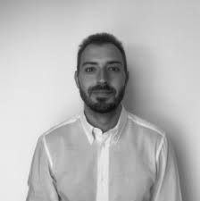
Corrado Sandini is a post-doctoral student at the Developmental Imaging lab of the University of Geneva and also works part time as a clinician in a private foundation for children and adolescents with neurodevelopmental disorders. After graduating in medicine at University of Genoa (Italy), he completed a PhD in neurosciences at the University of Geneva, which he obtained in 2018. His research activity focuses on understanding the interactions between environmental factors and brain maturation in neurodevelopmental disorders. He is particularly interested in developing new methodologies to represent the interactions between brain maturation and the different clinical manifestations of psychiatric disorders with the aim of developing new personalized treatments.

Ralf Stucker

Prof. Dr. Ann Swillen, KU Leuven & UZ Leuven
Department of Human Genetics & University Hospital Leuven
Leuven, Belgium

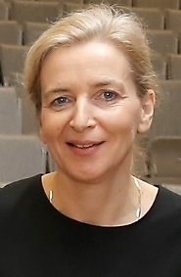
Ann Swillen is Professor at the Department of Human Genetics, KU Leuven and at the Department of Rehabilitation Sciences, KU Leuven (University of Leuven, Belgium). She is head of the Lab for Behaviour and Neurodevelopment. Trained as an clinical educational psychologist, she is also affiliated to the University Hospital Gasthuisberg/Centre for Human Genetics, an international centre of excellence in the field of clinical and molecular genetics. Her group has more than 25 years of experience and expertise in clinical follow-up and research of neurodevelopmental disorders such as intellectual disability (ID), developmental delay (DD) and autism spectrum disorders (ASD) in children, adolescents and adults with pathogenic Copy Number Variants (CNVs) such as microdeletions and duplications (22q11.2 deletions and duplications, 16p deletions and duplications, 22q13 deletions, etc.) resulting in more than 100 scientific papers on NDD’s and behaviors in CNVs. Through a multifaceted collaborative approach with many disciplines, we aim for four goals: (a) Deep phenotyping of persons with CNV’s with focus on development and behavior to better delineate and understand the developmental phenotype; (b) Identify mechanisms of ID/cognitive impairment and increased psychiatric risk; (c) Using specific neuro-genetic conditions (CNV’s) as homogeneous genetic models to better understand the interaction among genetic, behavioral and environmental factors in developmental disorders; (d) To develop psychoeducational tools www.geneticpuzzle.eu, to refine interventional (psycho-social) strategies and to improve the life of affected children and their families.

